Digital Talent Management Handbook

Introduction

Understanding your talent gaps

Developing a digital talent strategy

Building a digital team

Leading and managing a digital team

Guiding your digital transformation

Creating a productive and collaborative work environment

Building a modern team culture

Recruiting

Hiring

Onboarding

Ensuring happy and engaged employees

Keeping skills and ideas fresh

Building a movement and a presence

Addressing Connecticut specific challenges

How we wrote this guide

Appendix A: Interview questions

# Introduction

Regardless of mission, all government agencies are now technology organizations. Technology is used extensively behind the scenes to run the organization, manage, and do the work. The services an agency offers to the public are increasingly available online.

However, most of these technology efforts leave much to be desired. Systems are hard to maintain, interfaces are unfriendly, and errors are common. In the worst cases, getting services from the government still needs to be done in person or through the mail.

Governments need to get better at building and buying technology. To do so, agencies need to build in-house digital teams with expertise in building and buying modern technology services. These technology teams need to be cross-functional, with skills from user experience, visual design, product management, and software development. They need to be comfortable using the latest methods such as: agile and iterative development, human centered design, and DevOps. And lastly, these teams need to be empowered to make decisions, operate in a self-organizing manner, and initiate change where they see fit.

Enabling this requires a change to how governments recruit, hire, onboard, and retain digital talent. It requires shifting the work culture to be even more collaborative. Changes in management style happen hand in hand.

This handbook is intended to be a practical guide for federal, state, and local governments looking to build out their digital capacity to meet the needs in delivering technical products and programs.

## How to use this handbook

This handbook is written in chronological order, covering all of the steps it takes to build your digital teams.

Be intentional about increasing your digital capacity: start by understanding and quantifying your talent gaps. This will help reveal where digital teams are needed the most throughout your organization. Then use this research to build your digital talent strategy, which will likely involve a mix of hiring new talent and modernizing the skills of existing employees.

Building a successful digital organization requires focusing on three major areas:

1. **Talent**. Recruit, hire, and onboard digital talent into cross-functional, empowered, self-organizing teams. Commit to modernizing the skills of existing employees through continual education.
2. **Environment**. Build a collaborative work environment. Provide your teams with the tolls, physical space, culture, and leadership they need to succeed.
3. **Communication**. Instigate digital transformation throughout your organization by telling the stories of how you do the work. These stories will help inspire your organization.

Start small, and test the success of each initiative before rolling it out to a wider audience. What works elsewhere may not work here, so be prepared to iterate. Regular retrospectives will help you iteratively improve and build your organization.

## Intended audience

We expect this to be read by agency technology leadership: CIOs, team leads, and other hiring managers. Agency leadership such as commissioners and administrators should skim this handbook, paying particular attention to the leadership and culture sections. Both of those sections apply to the entire organization, not just the technical staff.

# Understanding your talent gaps

Every organization has gaps related to talent. These gaps may include skill sets and competencies missing from their ranks, a lack of diversity, or employees who don’t have the resources to be successful in their roles. However, few organizations intentionally and successfully understand these gaps. And organizations can only improve by first understanding where they are falling short.

However, in recent years, organizations in both the private and public sectors are increasingly focused on understanding their talent-related gaps — and what it will take to close them. Companies like Amazon have rolled out [daily assessment questions](https://www.cnbc.com/2018/03/30/amazon-employee-reaction-to-hr-programs-connections-forte.html) for their employees, and government agencies have devoted special task forces to take on the issue. Through these efforts, we’ve seen several strategies emerge for improving the way organizations assess and start to close their talent-related gaps.

## Listen to your current, past, and prospective employees

* Survey candidates in your hiring pipeline.
* Capture information as part of exit interviews.
* Conduct stay interviews to learn what current employees like and dislike about coming to work.
* Create other pathways for existing employees to safely and effectively share what they need.

## Document and benchmark your talent gaps

### Capture data related to talent-related deficiencies

* Identify talent goals. (e.g. reducing time to hire)
* Identify metrics associated with those goals. (e.g. number of days from job posting to start date)
* Measure the organization’s current performance as a baseline.

### Establish goals for your organization by comparing your metrics to those of high-performing organizations

* Focus comparisons on organizations who are leaders in that space (e.g. [USDS at the federal level](https://www.govloop.com/new-hiring-pilot-could-help-agencies-find-qualified-candidates-faster/)) since there is a great amount of variety among performance of government institutions.
* Organizations like Glassdoor are a good source of information on industry standards. (e.g. [How Long Should Your Hiring Process Take?](https://www.glassdoor.com/blog/how-long-should-interviews-take/))

### Review progress made in other organizations to build on what works

When possible, look at what’s been most successful in organizations with similar resources and structure. For example, it may be unreasonable for the State of CT to successfully employ the same tactics as an extremely large and well-resourced HR team. Model your efforts after successful efforts at organizations most similar to CT in terms of resources and regulations.

That said, some of the larger and more well-resourced organizations will be the most likely to measure and document progress made with respect to talent. For example, [Mobilizing Tech Talent](https://ourpublicservice.org/wp-content/uploads/2018/09/Mobilizing_Tech_Talent-2018.09.26.pdf) is an excellent resource for metrics and best practices in improving hiring tech talent into government.

## Take steps to close gaps

* Establish priority areas and goals based on the gaps you’ve identified.
* Work with staff closest to the issue areas to understand the current process and existing constraints.
  + Consider producing a process map ([example](https://talentsum.com/wp-content/uploads/2015/04/candidate-journey-map.png)) to clearly identify the steps in a process and to ensure other stakeholders also have that visibility.
  + Identify the aspects of the process that pose the biggest challenges and target these for improvement.
* Establish tactical steps for improvement.

## Hold yourselves accountable to progress

* Identify and empower individuals to implement improvement plans.
* Review progress at regular (and reasonable) intervals.
* Be transparent: report out publicly on your process and accomplishments.

## Checklist

* Involve staff in identifying talent gaps
* Look at similar organizations for inspiration
* Document gaps and identify benchmarks
* Hold yourself accountable for closing gaps

|  |
| --- |
| Case study: Durham, North Carolina The city of [Durham](https://durhamnc.gov/) in North Carolina conducts an annual workforce survey and publishes the results. While employee engagement surveys are standard across many levels of government, this survey’s feedback loop makes it stand out from the rest. In addition to traditional questions to identify pain points, the survey measures whether or not employees felt action was taken after the previous survey.  When conducting an employee engagement survey:   * Write clear, concise questions that touch on one issue at a time (avoid [double-barreled questions](https://en.wikipedia.org/wiki/Double-barreled_question)). Test these questions with a few people to ensure their meaning is straightforward. * Incorporate both open and closed questions. Open questions allow for longer, more personal responses, while closed questions have a fixed number of options to respond to (like yes/no or multiple choice). Open questions will generally produce better results. But they can also get tedious for respondents to answer, and introduce more complexity into the survey evaluation process. * Use the “[funnel” technique](https://www.qualtrics.com/experience-management/research/question-sequence-flow-style/) — start with questions that are easy respondents to answer, move into complex questions, and finish with simple questions. * Make responding as easy as possible. Only ask relevant questions, accept partial responses, and use an online survey tool that can be accessed from any device. |

# Developing a digital talent strategy

After you understand your talent gaps and established goals and metrics, it’s time to develop a digital talent strategy.. A comprehensive digital talent strategy will combine the following approaches:

* Recruiting new digital talent
* Recognizing and training existing technology talent
* Preparing government employees to work collaboratively with technical teams
* Leveraging alternative sources of talent
* Using technology to create additional capacity

## Recruiting new digital talent

Modernizing the skills of current technical workers in government is necessary, but it will take time and effort. To improve services today, you need to recruit and hire new digital talent into government. Hiring today means you will be able to leverage the fresh perspectives and new tools and technologies without delay.

This handbook covers: what skills to hire for and how to recruit, hire, and onboard new digital talent.

### Consider hiring for shorter durations

Governments tend to hire people as permanent employees. Hiring happens infrequently and is difficult because you are potentially employing someone for decades.

USDS, 18F, and CFPB have used fellowship mechanisms and special hiring authorities to hire digital talent into government for ‘tours of duty’ that can last a maximum of four years. The mechanism you use will depend on the hiring authorities available to you.

### Attracting talent to bright spots

The opportunity to be a cog in the wheel of a giant government bureaucracy won’t attract top talent. Hire digital talent into teams, creating bright spots of talent.

There a few different ways to create bright spots:

* **Centralized innovation hubs —** 18F (see: [collaboration approaches to see your project succeed](https://18f.gsa.gov/partnership-principles/)) and USDS are centralized innovation hubs. Teams work on projects for different agencies. One of the benefits of this approach is that it opens the door for teams to work on problems that span multiple agencies.[1] It also allows for shared solutions, resulting in economies of scale.
* **Innovation teams within a single agency —** These teams are part of the agency and share the mission and values. The teams can form around critical services, providing long-term support. They can build the strong, lasting relationships and trust needed to effect change.

## Recognizing and training existing technology talent

“*It’s common that there are dozens or even hundreds of civil servants who both know how the system works inside and out and have been trying to change it to improve outcomes for years. While it’s likely that building a delivery-driven government will require hiring new talent, failing to recognize, elevate, and support the champions you already have (and who have the battle scars) as a new generation of leaders can set a change agenda back years, even decades.*” — *Jennifer Pahlka* [2]

### Find people to guide new technology teams

New teams of digital talent will need to deliberately focus on building partnerships and mutual respect with existing government employees, while simultaneously learning how to navigate the bureaucracy. To accelerate this process, embed seasoned government employees into these new teams.

Find people in technology roles who are willing to guide and work with a new team while learning new methods. Recruit these folks from across government and bring them into your agency (use temporary assignments if you need to). Finding people that are the right cultural fit is important. Identify capable people who have been frustrated with the inability to get things done in their current roles, and give them a platform to shine. They will turn into your best agents of change.

Plan to send them to formal training for agile, human centered design, DevOps, and other skills as needed. They will learn on the job as well, but the investment in formal training will make this easier.

Embedding these folks in existing teams makes this easier.

* Preparing government employees to work collaboratively with technical teams

## Preparing government employees to work collaboratively with technical teams

All government employees — including those outside of your technology team — will need training and support to help them work collaboratively on technology projects. At a minimum, they will need to understand the basics of agile project management, human-centered design, and design thinking.

Plan to offer incentives and opportunities for continuously training your staff. Your staff needs to keep up with the pace of change in technology. The section on “Keeping skills and ideas fresh” discusses how to do this in detail.

## Leveraging alternative sources of talent

Hiring people is not the only way to access digital talent. Consider some alternatives to increase the digital talent density on your team:

* Partner with universities to **offer internships**. Government offers the ability for students to make an impact.
* Support and partner with **technology boot camps** such as General Assembly, or programs like Coding IT Forward, to hire recent graduates.
* Partner with **organizations like Code For America**.
* Bring in **freelancers** on short duration temporary assignments to solve a particular problem. This can work well for tasks that don’t need to be done frequently, such as setting up DevOps pipelines or uncovering security bugs.

These alternative options for talent work best when projects are well defined.

## Using technology to create additional capacity

Government agencies are increasingly asked to do more with less — smaller budgets, fewer staff. Many government organizations are used to thinking of technology as a cost center rather than a mission enabler. But the right technology can increase efficiency, helping to augment or replace some government jobs.

Although machine learning and artificial intelligence are often touted as necessary automation tools, they are difficult to implement well in environments that aren’t ready for modern technology. Luckily, there are often simpler alternatives to many labor intensive tasks:

* **Self-service, web-based tools** for common tasks like password resets and data edits
* **Software as a Service (SaaS) tools** — like Google Suite or Office 265 for collaboration — instead of hosting your own tools
* **Cloud-based hosting** instead of state-hosted data centers for compute and storage infrastructure
* **Web-based forms** (when forms are necessary) to replace mailing paper back and forth

Digital teams are well-suited to looking at entire processes end to end to determine where technology can add value.

## Checklist

* Create a comprehensive digital talent strategy
* Use technology to create additional capacity

|  |
| --- |
| Case study: UK Government Digital Service The UK Government Digital Service (GDS) is the oldest of the civic digital service teams. In many ways, it set the standards for teams in the United States, including 18F and USDS. GDS operates on a mixed model, hiring people into a centralized team, providing oversight for new IT acquisition, and staffing teams within agencies. Through this model, they have brought hundreds of technologists into the UK government.  The centralized team focuses on setting standards and building shared tools. For example, it’s responsible for the [Gov.UK design system](https://design-system.service.gov.uk/?_ga=2.48215079.183259153.1574016435-578254373.1574016435) that standardizes the look, feel, and interaction for UK government websites, as well as for shared services like [Verify](https://www.gov.uk/government/publications/introducing-govuk-verify/introducing-govuk-verify), an online identity management system.  GDS sets the standards for hiring and helps hire a variety of technologists into the UK government. These designers, engineers, product managers, and other technologists are placed within agencies and work with other government staff to design and build vital public services.  Another key to the GDS strategy for success is budget. GDS must approve any IT acquisition over £5 million. This helps ensure that large technology projects follow best practices. Each of these projects:   * Is user-centered * Is cloud-hosted * Adheres to the UK design systems * Uses a single voice to communicate to the public |

# Building a digital team

## Create teams of digital talent

Improving digital services requires organizational change, and it takes a team approach to get the traction needed. Create agile, cross-functional, and self-organizing digital teams around critical services. For example, you might want to put a team in place to focus on driver’s license and renewal services. Another team might focus on vehicle registration. Digital talent is more effective in focused teams, because digital teams will have an easier time introducing new methodologies to the organization.

## Keep teams small

*“If you can’t feed a team with two pizzas, it’s too large” —* Jeff Bezos

A small team is often going to be more efficient than a larger team. By keeping teams small, you can:

* **Save time** — Fewer people means you can spend less time learning how to work together and more time getting the work done.
* **Focus on quality, not quantity** — A small team may do fewer things at once, but they will do them thoroughly.

When you’re putting together a core digital team for a service or product, aim for a team of no more than 6 to 8 people.

## Encourage collaboration

It’s better to have many small teams working together than to have one large team. For example, the driver’s license and vehicle registration teams might share what they learn from user research. Since most people who register vehicles also have a driver’s license, these two teams may have more impact on the overall user experience by working together.

Even a team working on a single service won’t work in a silo. A digital team will need help from other parts of your organization, such as:

* Privacy and legal
* Cybersecurity
* Infrastructure
* Public relations and communication

## Include multiple roles on each digital team

Most government agencies are now technology organizations. They increasingly use technology to run their internal workflows and operations. And they are expected to provide user- friendly and self-service digital experiences for the people they serve. In-house digital teams are critical.

Most digital teams should have at least one of each role described below.

### Software developer

Developers design, implement, and maintain software applications. Developers may do this for custom software applications or commercial off-the-shelf software (COTS).

**Front-end software developers** build user-facing components. They work with UX and visual designers. **Back-end engineers** work with front-end engineers to build services that drive the interface. The software developers on your team:

* Write and maintain custom software applications
* Configure and customize COTS applications
* Help pre-process and analyze data
* Operate and monitor services in development, staging, and production

### DevOps engineer

DevOps engineers help product teams deploy code quickly, securely, and reliably. They work closely with software developers and:

* Write code to solve problems with software infrastructure, deployment, and operations
* Configure and maintain continuous integration and continuous deployment (CI/CD) pipelines to automatically build and test the software
* Define, configure, and secure the application's hardware and software infrastructure
* Configure and maintain the tools that monitor hardware and software
* Help software developers architect and develop software that is scalable and reliable

### Security engineer

Security engineers ensure the privacy of users by securing user data. This is essential, since many government systems deal with Personally Identifiable Information (PII) and Protected Health Information (PHI). Security engineers work closely with software developers and DevOps engineers. Their key tasks are to:

* Conduct regular security audits and scans
* Work with DevOps engineers to patch systems against vulnerabilities
* Help software engineers architect and develop secure systems

### Product manager

Government services should be managed the same way a company manages a commercial product. Product managers help determine the roadmap for your service, and they establish a product-market fit. Product managers work closely with UX researchers and designers and:

* Guide the team in deciding how to iteratively build features for users
* Define the product (service) vision by describing future goals and features
* Work with the team to define the technical and feature roadmaps
* Gather and analyze usage data to drive changes
* Create assets for users, stakeholders, and government officials with the communication team
* Apply for grants and other funding

### User experience (UX) researcher

UX researchers learn about and empathize with the users of your service. They test the usability of each feature. UX researchers work closely with UX designers, content strategists, and product managers. UX researchers:

* Understand who the users of the service are
* Help the team understand what the users expect by conducting research (see<https://methods.18f.gov/>)
* Work with UX and visual designers to develop interfaces that are accessible, usable, and joyful
* Conduct usability tests on features
* Work with the product manager to define the next iterations

### UX designer

UX designers turn user research into interactions and interfaces that work for everybody. They design how someone will interact with a service. UX designers work closely with UX researchers, visual designers, content strategists, and front-end engineers. Their key responsibilities are to:

* Generate low fidelity prototypes
* Work closely with visual designers to define the look and feel of applications
* Plan and conduct usability testing for prototypes and implemented interfaces

### Visual designer

Visual designers build the look and feel of the service. They ensure that the design provides a consistent and accessible user experience. Good design reflects the purpose of the service. Veterans’ benefits applications should look different from picnic table reservations. Visual designers work closely with UX designers, content strategists, and front-end developers. They:

* Build the visual style guide for the application
* Design implementation-ready interfaces
* Ensure accessibility throughout the design

### Content strategist

Government services often have complex information to communicate to users. Examples include: eligibility rules for benefits, applicable laws and regulations, and complex data. Content strategists ensure that content is easy to read and presented where it’s needed. Content strategists work closely with UX and visual designers to:

* Develop user workflows and information architecture
* Create and edit plain language content for the service and any related assets
* Ensure content is understandable and actionable
* Define the voice and tone of your communication
* Develop content guidelines for all members of the team to use
* Help tell user stories

## Create cross-functional digital teams

Your digital teams need to be cross-functional. Structure teams so that most of the work can be done within the team. A research-heavy project that needs to continuously borrow a UX researcher from another team won’t be as efficient as one with an embedded researcher. The composition of your team depends on the project type and stage of development.

### COTS projects

With commercial products, use these questions to help you identify the right team members:

* Does the platform allow you to change the look and feel? If there’s limited flexibility, the team won’t need UX and visual designers.
* Do existing staff have experience with the platform? For example, for Salesforce, you’ll need Salesforce developers. If you don’t have the in-house experience, you’ll need to bring on a new developer or allow time for training.
* Who’s responsible for the security of the system? With Software-as-a-Service (SaaS), the software company will ensure the system’s security and you won’t need a security engineer.

### Software projects that are mostly contracted out

Many governments contract out most of their software development. You’ll still need a cross-functional digital team to manage their work. Creating mixed government and contractor teams is a good idea for knowledge transfer. Create a one-badge culture, and treat each member the same. Roles you’ll need:

* Senior software developer to review the code written by the contractors
* UX researcher to work with the UX researchers on the contractor team and ensure that the government team builds institutional knowledge about its users

### Custom software projects

When you’re developing custom software, you’ll need representation from all of the areas of expertise we described above. At different stages of development, you may need to add additional capacity in one or more areas.

## Checklist

* Create cross-functional teams of digital talent of no more than 6 to 8 people each
* Decide the composition of your team based on the type of project: COTs, mostly contracted out, or custom software built in-house
* Vary the size and composition of your team based on which phase your project is in: discovery, alpha, beta, live

## Recommended reading

* [18F labor category descriptions (for agile procurements)](https://agile-labor-categories.18f.gov/)
* [What each role does in a service team](https://www.gov.uk/service-manual/the-team/what-each-role-does-in-service-team)

|  |
| --- |
| Case study: Georgia Digital Service When Nikhil Deshpande started the [Georgia Digital Service](https://digitalservices.georgia.gov/) (GADS), he knew it would be hard to hire digital talent with the breadth and depth of skills needed. He developed an approach that would allow him to supplement internal staff with a strong vendor pool as needed.  First, Deshpande needed to hire a team. He used his strong personal network to identify and hire an internal team of strategists. He started out by filling these strategic positions primarily with contractors. Over the next year, he worked with human resources to hire permanent staff. His internal team has now grown to a core team of 15.  Deshpande and his core team then turned their attention to creating a multi-disciplinary vendor pool. To supplement their internal skill set, they needed additional expertise in content strategy, user experience, product management, development, and testing. After rigorous evaluations, GADS identified and retained multiple vendors in each area of expertise. Now they pull these vendors into projects as necessary.  The state and vendor teams work together to support GADS. Strong project management practices allow the vendors to work well with each other and the state team. Shared tools, like Slack and Jira, allow teams to collaborate without friction.  Tips for procuring high-caliber vendors:   * Look for specific evidence of the skills you need. When GADS issued an RFP for Drupal engineers, it required respondee vendors to get most of their business from Drupal engagements. It also required them to make public contributions to the Drupal community. * Use a multi-tiered evaluation approach. Filter out unqualified vendors through a short written submission. Then invite the most qualified vendors to participate in a technical challenge where subject matter experts can evaluate their skills. * Work with your procurement team to ensure that your process follows internal policies. * Scope work in short-term projects. You can add options for additional work based on vendor performance. |

# Leading and managing a digital team

*“The gardener cannot actually ‘grow’ tomatoes, squash, or beans — she can only foster an environment in which the plants do so.” —* General Stanley McChrystal

## Serve your teams

As a [servant leader](https://www.shrm.org/resourcesandtools/hr-topics/organizational-and-employee-development/pages/the-art-of-servant-leadership.aspx), your job is to:

* Empower the people who work for you
* Unlock the potential of your employees by allowing them to grow
* Explain the mission, strategy, and context for the work
* Remove any blockers the teams encounter
* Provide executive air cover for the methods, decisions, and output of the team
* Help teams and individuals make decisions

Always ask your teams what they need from you to be successful and schedule regular check-ins to stay up to date with what they need.

## Empower your teams

To be most effective, digital teams need the autonomy to self-organize, self-manage, and self-execute. Trust and empower those closest to the work to make the right decisions.

## Nurture risk tolerance

Foster a blameless culture. Don't chastise teams when things go wrong, or they’ll be less likely to take bold, innovative steps in the future. Encourage the teams to use [their retrospectives](https://www.scrum.org/resources/what-is-a-sprint-retrospective) to constantly inspect and adapt.

## Be a vocal advocate

Introducing new methods of working can cause fear, uncertainty, and doubt. Digital teams need to collaborate with all of the other parts of your organization, and they employ methods that are sometimes unfamiliar to traditional government organizations — like design thinking, human centered design, agile, and DevOps.

A traditional government project in the waterfall-style provides a detailed schedule of every activity and document written from day zero to go-live. An agile project eschews the master schedule in favor of describing progress in terms of value delivered to users.

Agile teams have backlogs and roadmaps, but can only tell you with certainty what’s being delivered in the next [sprint](https://en.wikipedia.org/wiki/Scrum_Sprint). The lack of precise schedule and comprehensive documentation in agile can seem chaotic to those used to the rigid structure of waterfall.

Your role will be to support and advocate for the team’s approach. Build and maintain relationships across the organization and use those relationships to help your teams succeed.

## Be an active participant

Make time for your teams and participate in workshops and other events. For example:

* Attend and participate in workshops, interviews, and usability tests
* Encourage access to users
* Help teams prioritize work and build their backlog

As an executive, your participation lends legitimacy to the activities. When others in the organization see you as an active participant, they’ll be more likely to join in and take things seriously.

## Checklist

* Have I scheduled regular check-ins with my team?
* Have I asked my team what they need to be successful?
* Can I explain to others in plain language what my team is doing?
* Does my team have a way to showcase their work incrementally to all my staff?
* Have I done all I can do to remove artificial barriers to my team being productive?
* Can I clearly articulate what direct benefit my team provides to the public?
* Is my team working well with others? If not, why not?

# Guiding your digital transformation

By introducing digital teams, you’re changing the way the entire organization operates. Acknowledge the disruption, but make it clear that the change is here to stay. Plan to bring the rest of your organization along. You will fail to make progress if you alienate the rest of your organization.

Spend the effort to educate:

* Talk about the methods just as much as you talk about the output
* Ask your digital teams to lead workshops that teach others about the methods they’re using
* Offer training opportunities to your staff

For these and similar ideas, see: “Keeping skills and ideas fresh.”

Pair each team with an internal agency champion. The champion will be someone who has been at the agency for a long time and has the relationships to help pave a smoother path for the team. The champion will help the team navigate the bureaucracy.

## Structure for success

### Report to the highest levels

***“****The most successful, delivery-driven government efforts tend to have technology leadership reporting to the highest levels of the organization, not buried within it.” [3]*

In turn, digital teams should report to the highest levels in the technology organization. Initially, digital teams are disruptive. They will need significant executive air cover.

### Designate one team lead

Each team should have a single lead. Often, it makes sense for this person to be the product manager on the team. The lead should be adept at explaining what the team is trying to achieve to various levels in the organization. Other than the lead, the teams work best in a flat structure. Everyone’s voice is equally important. Everyone has ownership.

## Change how you measure progress and success

Digital teams and the new methods they introduce require changes in how you measure progress.

### Measure progress by value delivered to the user

The real measure of progress is working software. Each iteration should produce shippable working software. Attend sprint reviews and ask for demos of the software. Asking your team to generate progress reports is a waste of their time. Always include a demonstration of the software in presentations to agency executives.

### If it doesn’t work for the user, it doesn’t work

Your opinion of a particular feature, interaction, or visual design is irrelevant. Ensure that the teams are empowered to conduct usability tests of every new feature. The software your teams build should work for the users. Rather than expressing your personal opinion, always ask how the software was received by potential users.

### Demand and measure quality and performance

Automated tooling can help you measure how well your teams are building software. Code build and deployment pipelines should have automated scans for: running tests and reporting test coverage, accessibility, security, code quality and readability. Learn how to use the same tools and dashboards that your team does to reduce any reporting overhead. This allows you and the team to continuously measure quality.

Establish a Quality Assurance Surveillance Plan (QASP). The QASP specifies how the team will measure quality and what metrics they need to achieve. See a [sample QASP here](https://github.com/18F/technology-budgeting/blob/master/handbook.md#appendix-b-sample-quality-assessment-surveillance-plan-qasp).

### Measure performance

The following metrics can be used to measure the performance of your team(s)::

|  |  |
| --- | --- |
| **Metric** | **Description** |
| User satisfaction | The degree to which users find digital solutions useful and usable. |
| Deployment frequency | How often teams deploy code to production. (The highest-performing organizations ship code hundreds to thousands of times per day.) |
| Lead time for changes | How long it takes to go from code commit in development to code successfully running in production. |
| Mean time to recover (MTTR) | How long it takes to restore service when an incident occurs. |
| Change failure rate | What percentage of changes either result in degraded service or subsequently require remediation. |
| Lead time from validated procurement need to quality minimum viable product (MVP) | How long it takes to go from a validated digital/IT procurement need to a quality minimum viable product (MVP) deployed to an initial subset of users. |
| Digital talent density | The ratio of qualified internal digital experts to external digital/IT contractors. (Digital/IT is a critical core competency that can’t be fully outsourced in today’s world.) |
| Employee Net Promoter Score (eNPS) | The degree to which employees are willing to be ambassadors for the organization. |
| API proliferation | Number of applications/services/reports powered by APIs. |

## Hire digital savvy leadership

*“Having senior leaders who understand technology and its importance to the mission is fundamental for ensuring a high level of government effectiveness.” [4] — Jennifer Anastasoff and Jennifer Smith*

All government agencies increasingly rely on technology. They need technology to be more efficient in the face of shrinking budgets. And they need it to better serve their constituents. All leadership in a government agency needs to be digital savvy.

### Technology leadership

Hire technology leadership with hands-on experience managing modern software development projects. You need shovel-ready practitioners, not thought leaders. They should be passionate about evaluating and using new technologies, but without falling for the hype. They should be well-versed in design thinking, human centered design, DevOps, and lean and agile methods.

### Other leadership

All executive leadership in an agency must be digital savvy. They have to recognize that technology is a mission enabler and not a cost center. Digital teams not only develop software, but also help redesign the corresponding processes. Human centered design is just as effective for policy changes as it is for software. Hire executive leadership with a proven track record of managing technology rich organizations.

## Checklist

* Empower your team by pushing decision-making to the team level
* Foster a blameless culture
* Be a vocal advocate for the methods your team uses
* Lend your support by being an active participant in team workshops and activities
* Educate the rest of the organization to avoid alienating them
* Pair each digital team with an internal champion
* Structure your organization for success
* Measure project progress by value delivered to the user
* Establish a Quality Assurance Surveillance Plan (QASP)
* Hire digital savvy executive leadership
* Hire technology leadership with hands-on experience

## Recommended reading

* [Delivery Driven Government](http://s3-us-west-1.amazonaws.com/codeforamerica-cms1/documents/Delivery-Driven-Government.pdf)
* [Five qualities of a digital leader](https://medium.com/swlh/five-qualities-of-a-digital-leader-9b58c398a312)
* [The art of servant leadership](https://www.shrm.org/resourcesandtools/hr-topics/organizational-and-employee-development/pages/the-art-of-servant-leadership.aspx)
* [De-risking custom technology projects: A handbook for state grantee budgeting and oversight](https://github.com/18F/technology-budgeting/blob/master/handbook.md#appendix-b-sample-quality-assessment-surveillance-plan)

# Creating a productive and collaborative work environment

## Create a collaborative physical space

Physical space can encourage and facilitate collaboration.

As teams envision and build products, they need space for conducting in-person workshops with users and stakeholders. A useful space for workshops and trainings has:

* Enough room for 20 to 30 people to move around
* Plenty of free wall space for stickies, posters, and journey maps that attendees can gather around
* Whiteboards for brainstorming (tip: use [ideapaint](https://ideapaint.com/) if physical boards aren’t available)
* Equipment to project or display slides (for instructions and other materials)

## Ensure your teams have modern hardware and software

Digital team members will need access to modern software and services to do their jobs well. They will likely already be familiar with many tools commonly used in industry and will be productive with them. The tables later in this section include examples of popular tools, but these aren’t exhaustive lists — ask your staff what tools they need.

“*Of public sector job seekers, 43% of 18 to 34 year olds indicated that the government’s readiness to adopt the latest technology had a major impact on their willingness to work in government*.” [5]

## Have a remote-first mindset

A geographically distributed team needs to be able to access data, documents, and tools from anywhere.

* Invest in decent collaboration tools
* Work with your network and security teams to ensure tools and other services your team relies on can be accessed remotely

In the tables below, we’ve identified tools that facilitate remote work as ‘remote friendly.’

### Project management and other tools

|  |  |  |
| --- | --- | --- |
| **Name** | **Purpose** | **Remote Friendly** |
| [Miro](https://miro.com/) | Allows creation of product management, UX, and other types of online boards | X |
| [Trello](https://trello.com/en) | Kanban-style list making application for agile project management | X |
| [Jira](https://www.atlassian.com/software/jira) | Bug tracking and agile project management | X |

### Collaboration tools

Communication tools are a constant barrier for government employees. Increase productivity and foster creative, serendipitous problem solving by procuring collaborative editing and chat software.

|  |  |  |
| --- | --- | --- |
| **Name** | **Purpose** | **Remote Friendly** |
| [Slack](https://slack.com/) or Microsoft Teams | Real-time chat | X |
| [Zoom](https://zoom.us/) | Video conferencing | X |
| [Google Docs](https://docs.google.com/) | Collaborative creating and editing | X |

Microsoft Teams also allows for video conferencing and collaborative document authoring in addition to real-time chat.

### Tools for engineers

|  |  |  |
| --- | --- | --- |
| **Name** | **Purpose** | **Remote Friendly** |
| [Github](https://github.com/) or [Gitlab](https://gitlab.com/) | Distributed version control, features to make collaborating on code easier, and features for issue tracking | X |
| [Code climate](https://codeclimate.com/) | Code quality and other code metrics static scans |  |

### Tools for designers

|  |  |  |
| --- | --- | --- |
| **Name** | **Purpose** | **Remote Friendly** |
| [Sketch](https://www.sketch.com/) | Create high fidelity mockups and prototypes and build UI components that can be reused across projects |  |
| [Invision](https://www.invisionapp.com/) | Interactive prototypes and feedback | X |
| [Abstract](https://www.abstract.com/) | Version control for Sketch files |  |
| [Axure](https://www.axure.com/) | Prototyping |  |

## 

## Checklist

* Use the list above to equip a new team with commonly used software and tools
* Start procuring these as early as possible, since most large organizations have lengthy procedures for permitting and acquiring new tools and software
* Establish a simple process for teams to request additional software and services

## Recommended reading

* [How rethinking your workspace can spur innovation](https://medium.com/@BloombergCities/how-rethinking-your-workspace-can-spur-innovation-ef6ff553b75b)

|  |
| --- |
| Case study: 18F [18F](https://18f.gsa.gov/), a tech team within the General Services Administration, partners with agencies to help them build and buy technology that improves the user experience of government services. With team members all over the country, 18F employs a number of strategies to [make their “remote first” mindset work](https://18f.gsa.gov/2015/10/15/best-practices-for-distributed-teams/):   * They use modern collaboration tools, shared cloud storage, and collaborative document editing to make it easy for remote teams to chat, meet, share work, and preserve decisions. * They require each team member to be at their own computer during meetings to ensure that remote team members have a voice equal to that of those in the office. * They adjust work hours to provide enough overlap between employees in different timezones. Staggered hours across time zones allows the teams to spend 12 hours per day delivering client value, and everyone is online working between 12pm and 5pm EST. |

# Building a modern team culture

*“Culture eats strategy for breakfast.” [6]*

Building the right organizational culture is the most important thing you can do. The right organizational culture:

* Guides everyday interactions between the people on your team
* Creates an environment where people are happy to come to work
* Helps with recruiting and retention
* Increases team performance because everyone is aligned around common goals and values
* Creates an inclusive environment
* Determines how leadership and teams react to failures and setbacks

Culture is built and sustained intentionally. Don’t expect to organically grow into the culture you want.

## Understand the connection between culture and performance

The 2014 State of DevOps Report[7] did the research to identify a predictive link between organizational culture and performance. The cultural practices and norms that characterize high trust organizations — good information flow, cross functional collaboration, shared responsibilities, learning from failures, and encouragement of new ideas — correlate strongly with high performance.6

Westrum provides a useful typology that contrasts the qualities of three different types of organizational culture:

|  |  |  |
| --- | --- | --- |
| **Pathological** | **Bureaucratic** | **Generative** |
| Power oriented | Rule oriented | Performance oriented |
| Low cooperation | Modest cooperation | High cooperation |
| Messengers shot | Messengers neglected | Messengers trained |
| Responsibilities shirked | Narrow responsibilities | Risks are shared |
| Bridging discouraged | Bridging tolerated | Bridging encouraged |
| Failure leads to scapegoating | Failure leads to justice | Failure leads to inquiry |
| Novelty crushed | Novelty leads to problems | Novelty implemented |

Most traditional government organizations tend to be bureaucratic. However, digital teams thrive in generative cultures, which allow for innovation and experimentation.

## Strive for a generative culture

[re:Work from Google](https://rework.withgoogle.com/guides/understanding-team-effectiveness/steps/identify-dynamics-of-effective-teams/) identifies five characteristics of effective teams, and these all support a generative organizational culture:

1. **Psychological safety** — team members feel safe to take risks and be vulnerable in front of each other
2. **Dependability** — team members get things done on time and meet the high bar for excellence
3. **Structure and clarity** — team members have clear roles, plans, and goals
4. **Meaning** — work is personally important to team members
5. **Impact** — team members think their work matters and creates change

Next, we’ll break down the basics of encouraging these cultural characteristics.

### Psychological safety

While all aspects of culture start at the top, creating a psychologically safe environment is something only leadership can do. Here are some of the key actions for building psychological safety.

**Demonstrate willingness to try-fail-learn.** The best signal leadership can send to encourage experimentation is taking failures in stride. Provide executive air cover for experiments and new ideas. Be prepared to defend the actions of your team to others in your organization. Don’t assign blame. Instead, encourage teams to learn from failures. Understand that not all innovation leads to success. If necessary, work with teams to design smaller experiments with reduced impact.

**Require blameless retrospectives.** Empower teams to make changes in how they work. It’s important to act on all follow-ups from retrospectives. Through action, you’ll show that learning from retrospectives is important to you.

* [How to run an agile retrospective](https://www.atlassian.com/team-playbook/plays/retrospective)

**During meetings and workshops, encourage all voices to be heard.** Work through how you might implement a suggestion, rather than rejecting it immediately. Discourage interruptions. Create multiple avenues for people to contribute. For example, some people may not feel comfortable speaking up, but might be happy to write some thoughts down on a post-it.

**Create opportunities for feedback.** Regularly ask for feedback through employee surveys. Ask for feedback on organizational initiatives and on leadership. Act on the feedback you receive. Your employees will participate when they see that their opinions have value and result in change. Create mechanisms for anonymous feedback as well. Not everyone is going to feel comfortable being candid with feedback.

### Dependability

Dependability is an individual trait. As a team member, you have to personally be dependable. As a leader, you have to support and encourage dependable behavior.

**Encourage employees to be accountable and responsible for their actions.** Team members shouldn’t need to fear criticism or censure when they own their actions. Create an environment where team members are supported when they accept responsibility for their actions.

**Help the team manage commitments.** As a leader, your job is to ensure that external deadlines are realistic. Teams that are strapped for time will miss deadlines and produce low-quality work. Planning should always take into account the velocity of the team and respect work-life boundaries.

**Remove blockers and distractions.** To help team members get things done on time, remove any blockers they encounter. Constantly pave the way for a team to be productive. Attend standup meetings to understand daily blockers. Similarly, remove distractions in the workplace. Eliminate distractions such as noise and unnecessary meetings.

**Be clear about expectations.** Be clear about your expectations of employees. Specify and document expectations around accountability, ownership, and dependability. This should include expectations around technical excellence. Everyone on your team should understand the quality of work they are expected to produce and how that quality will be measured.

### Structure and clarity

**Clarify and document roles.** Each team member should understand their role in the organization and on their team. Document the definition and boundaries for each role. In smaller teams, everyone does everything. As your teams grow, role definitions will provide structure and clarity.

**Help set and achieve goals.** Personal growth is important for employee retention. People will stay in their jobs if they know that they are learning and growing. Help each team member set goals for what they personally want to achieve. Then do your best to create opportunities for people to meet their goals.

Teams should also collectively set goals and support each other to achieve them. The [Objectives and Key Results](https://rework.withgoogle.com/guides/set-goals-with-okrs/steps/introduction/) (OKRs) framework from Google works well to set goals and track progress at multiple levels in your organization. OKRs help align individual and team goals with organization goals. Each goal should have an associated plan on how to achieve it.

* [How we use OKRs on GOV.UK, the UK government website](https://visitmy.website/2019/02/21/how-we-use-okrs-gov-uk/)

### Meaning and impact

**Remind people of the mission.** Have a clear and concise mission, and include vision and values statements on posters in your physical space. The constant reminder is important so that teams don’t forget the larger picture.

* [Our values: a series of posters from the USDS](https://medium.com/the-u-s-digital-service/our-values-1fc02b53598)
* [Posters from UK’s GDS](https://govdesign.tumblr.com/)
* [A set of posters emphasizing 18F’s principles and values](https://github.com/18F/18f-posters)

**Build with shared empathy.** To understand the potential impact of their work, encourage everyone on the team to participate in Discovery. By interacting with users, the team will understand the problem they are trying to solve and the impact that problem has on everyday lives.

**See the impact of the work.** Have everyone on the team participate in usability tests to observe how their solution makes things easier for users. Write frequently about the impact of the work that you are doing. This storytelling is important, both within the team and across your organization.

**Assign people to projects they are passionate about.** Team members who are passionate about a particular topic will be excited about the work they do — and be more productive. When you can, give people a choice by asking them which projects they care about and would like to work on.

## Create a welcoming and inclusive environment

A welcoming and inclusive culture empowers people to provide outstanding public service.

### Create and enforce a Code of Conduct

A Code of Conduct puts into writing how you expect people to behave in the workplace and at work events. It codifies your commitment to an inclusive environment. Create a documented process for enforcing the Code of Conduct and an anonymous process for reporting violations of the Code.

* 18F has a [Code of Conduct](https://github.com/18F/code-of-conduct/blob/master/code-of-conduct.md) that you can adopt and modify as necessary

### Empower people to speak up

Create a community where everyone feels empowered to speak up. It’s useful to do this in a town hall setting, as well as in 1:1s. Create office hours for people to drop in and chat about anything. And create an anonymous feedback forum so that those who are uncomfortable bringing up issues in person can do so anonymously.

### Use inclusive language in all communications

“*As we build government services, we want to ensure they are accessible and welcoming to everyone who needs to use them. Inclusive language helps to be more accurate and build trust with our users*.” [8]

Use inclusive language in all communications with your organization and the services you build. These resources can help:

* This [inclusive content guide from 18F](https://content-guide.18f.gov/inclusive-language/) is short and easy to internalize for all communications.
* The Ontario Digital Service has a useful [inclusive design toolkit available online](https://www.ontario.ca/page/inclusive-design-toolkit).

### Provide training on unconscious bias

Unconscious bias is “learned stereotypes that are automatic, unintentional, deeply ingrained, and able to influence behavior.” [9] And everyone has these biases.

Unconscious bias training helps create awareness for this ingrained bias. Have everyone on your team attend unconscious bias training. This will help improve everyday interactions. It will also help during the interview process as you attempt to build a diverse team.

* Australia’s Queensland government has a [great set of resources on unconscious bias training](https://www.forgov.qld.gov.au/unconscious-biases)

## Checklist

* Identify where your organization lies on the Westrum category of organizational cultures, and move towards a generative culture
* Conduct team and organization-wide blameless retrospective
* Regularly ask for feedback on organizational initiatives
* Encourage employees to be accountable and responsible for their actions
* Remove workplace distractions
* Remove blockers
* Set organization, team, and individual goals using something like [Google's OKR framework](https://rework.withgoogle.com/guides/set-goals-with-okrs/steps/introduction/)
* Have everyone participate in Discovery and usability testing
* Assign people to projects they are passionate about
* Create and enforce a Code of Conduct
* Have everyone attend unconscious bias training
* Use inclusive language in all communications

## Recommended reading

* [How to Create a Great Team Culture (and Why It Matters)](https://queue.acm.org/detail.cfm?ref=rss&id=3323993)
* [Diversity, Equity, and Inclusion at TTS](https://handbook.18f.gov/diversity/)
* [Guide: Inclusive Language](https://content-guide.18f.gov/inclusive-language/)
* [Sample Code of Conduct (Ontario Digital Service)](https://docs.google.com/document/d/1heWtqC8AnAF4-5FNEdX311o5E4FPNnfboOxbsTpYmco/edit#heading=h.1xz7dk9v8pux)
* [A typology of organisational cultures](https://qualitysafety.bmj.com/content/13/suppl_2/ii22.full)
* [Inclusive design toolkit](https://www.ontario.ca/page/inclusive-design-toolkit)
* [How to reduce unconscious bias at work](https://lattice.com/library/how-to-reduce-unconscious-bias-at-work)
* [Survey to measure team culture](https://18f.gsa.gov/2019/10/29/culture-climate-survey/)

### 

|  |
| --- |
| Case study: Ontario Digital Service Direct communication lines between staff and leadership help empower staff to create change in their workplace. Hilary Hartley, Chief Digital Officer of the Ontario Digital Service, knows this from her time as a founding member of 18F. 18F’s [Diversity, Equity, and Inclusion](https://handbook.18f.gov/diversity/) policy is a model for any level of government.  Ontario Digital Service adopted these principles into the People Board, a group whose mission is to make work better. They engage employees to create change in the office, support diversity and inclusion initiatives, and represent employee voices to senior management.[10] A representative from the People Board sits on the Senior Management Table to advocate for employees. This representative is elected by peers based on their capacity to represent staff voices and perspectives.  People Board members meet every two weeks for the six months of their term, and can only serve two consecutive terms to ensure other staff get an opportunity to participate.  Employees know that the People Board represents them fairly, and as a result, elected members are trusted advocates. They create a feedback loop between employees and management that motivates employees to change their workplace. |

# Recruiting

## Nurture your reputation

Building a reputation as an organization committed to digital talent takes time. To attract the best talent, make recruiting an ongoing activity — not just one that you engage in when you have a job opening. Here are some basic things you can be doing all the time to build your reputation.

**Maintain an online presence.** Talk about the work you do. You can do this through:

* [Medium](https://medium.com/) articles
* Twitter posts
* LinkedIn articles and profiles of your team members
* [Slack](https://slack.com/) communities (e.g.,  [newhaven.io](https://newhavenio-slackin.herokuapp.com/) and [CT UX](https://tinyurl.com/CTUXPAslack2))

**Share details about your culture, benefits, and commitment to staff** — not just the mechanics of the work you do. When you speak and write, emphasize what makes your team unique.

**Be active in the civic technology community.** Encourage members of your team to attend and speak at conferences, meetups, and other events When the time comes to hire, the caliber of candidates will reflect your authentic engagement with the community.

For more details see the “Building a movement and a presence” section.

## Write an appealing position description

### Use plain language

Government is full of jargon and alphabet soup. It’s likely that candidates outside of government could bring useful skills and experience. To access these potential candidates, you’ll need to make sure they can understand what you’re looking for.

### Attract outside applicants

Do your research to make sure that your job description will get in front of the right people. For example, use job titles like those found outside government. More job seekers are likely to understand a post for “Software Developer” more than one for an “IT Specialist APPSW.”

Look at job postings outside of government and write position descriptions that mirror them. Industry applicants will find these more familiar.

### Be selective about your must-haves

Too often, job descriptions list every single technology under the sun. Narrow the list down to the skills you really need. For example, if you’re willing to train someone to use Invision, experience with Invision isn’t required for candidates.

Shorter, more realistic requirements lists show that you understand what you need. And they’ll also bring in a more diverse applicant pool.

"*Men like to apply to jobs for which they meet only 60% of the qualifications, women are much more likely to hesitate unless they meet 100% of the listed requirements.*” [11]

|  |
| --- |
| Outline of a position description   * Location * Salary range and benefits * Who may apply (citizens, existing employees, the public, etc) * Short mission statement and role summary * 3 to 5 key objectives for the role * How applications will be evaluated * A distilled list of the top priority qualifications   The position description outline is adapted from 18F’s position descriptions, viewable here: <https://join.tts.gsa.gov/> |

In addition to most of the sections above, you can consider adding what the new hire will do in one, three, six, and 12 months. This is especially effective for roles that are shorter term ‘tours of duty’ in the government. This also reassures candidates that you have meaningful work for them right away.

You can write your position descriptions based on existing, similar descriptions. Check these job boards or organizations for inspiration.

* <https://join.tts.gsa.gov/>
* <https://digitalservices.georgia.gov/careers>
* <https://digitalservices.sfgov.org/joinus/>

Companies that work almost exclusively with government can also be a good reference for civic-oriented job postings. Here are some examples:

* <https://www.navapbc.com/careers/>
* <https://adhocteam.us/join/>
* <https://skylight.digital/join/>

### Resources

* [Textio Hire](https://textio.com/products/) can help you write better, more inclusive position descriptions
* [Hemingway App](http://www.hemingwayapp.com/) makes your writing clearer
* [5 must-dos for writing inclusive job descriptions](https://business.linkedin.com/talent-solutions/blog/job-descriptions/2018/5-must-dos-for-writing-inclusive-job-descriptions)
* [Why women don't apply for jobs unless they're 100% qualified](https://hbr.org/2014/08/why-women-dont-apply-for-jobs-unless-theyre-100-qualified)
* [Tools for Government Hiring](http://www.govtalent.org/)
* [Improving the Hiring Process](https://medium.com/@bellmar/sre-as-a-lifestyle-choice-de9f5a82d73d)

## Attract candidates new to government

Government often can’t compete with industry on salary. To counter this, lead with a strong mission statement and focus on the agency’s impact.

The [San Francisco Digital Services](https://digitalservices.sfgov.org/) website does this well with a concise paragraph:

*“We’re working on critical issues like affordable housing, small businesses, legal aid for immigrants, and more. Our team is also building the city’s website from the ground up.”*

The first sentence refers to impactful critical issues that are part of the city’s mission. This draws the applicant in. A job description for a product manager similarly describes the mission aspect first.

*“You will engage with permitting departments and customers to understand where there is greatest need and opportunity, and you will own the overall product roadmap for digital permitting.”*

Anyone who’s tried to get a permit with the city will want to work on making that process better.

Candidates like hearing about what they’ll be working on. Include short descriptions of the projects (or similar ones) they’ll be working on. These can be simple descriptions.

*"Our team is also building the city’s website from the ground up.”*

## Advertise your job opening

Don’t expect to put a job opening online on your government website and have lots of great candidates apply. To ensure that you attract a qualified and diverse candidate pool, you’ll need to advertise your job opening

### Post your job opening online

In addition to posting your job in the official government listing, post jobs where candidates are. The more people who see or hear about your job opening, the more likely you are to have the right candidates apply. Here are key places to post:

* [LinkedIn](https://www.linkedin.com/)
* [Indeed](https://www.indeed.com/)
* [Design Gigs for Good](https://www.designgigsforgood.org/)
* [Public Interest Tech Job Board by Code for America](https://jobs.codeforamerica.org/)
* [Tech Jobs for Good](https://www.techjobsforgood.com/)
* Slack communities (e.g. [newhaven.io](https://newhavenio-slackin.herokuapp.com/) and [CT UX](https://tinyurl.com/CTUXPAslack2))

The following boards help reach candidates who are often under-represented in technology:

* [People of Color in Tech](https://www.pocitjobs.com/)
* [Remote Woman](https://remotewoman.com/)

Get everyone you know to use their social media channels to spread the word about your job opening on Twitter, LinkedIn, and Facebook. You can help by providing text people can copy and paste. These messages can be simple, like the examples below:

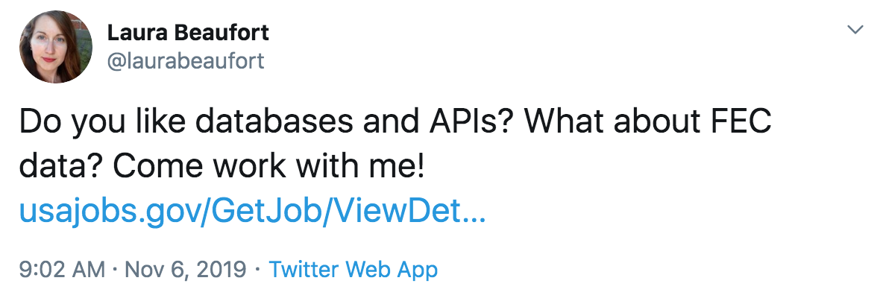

<https://twitter.com/laurabeaufort/status/1192079706423746560>

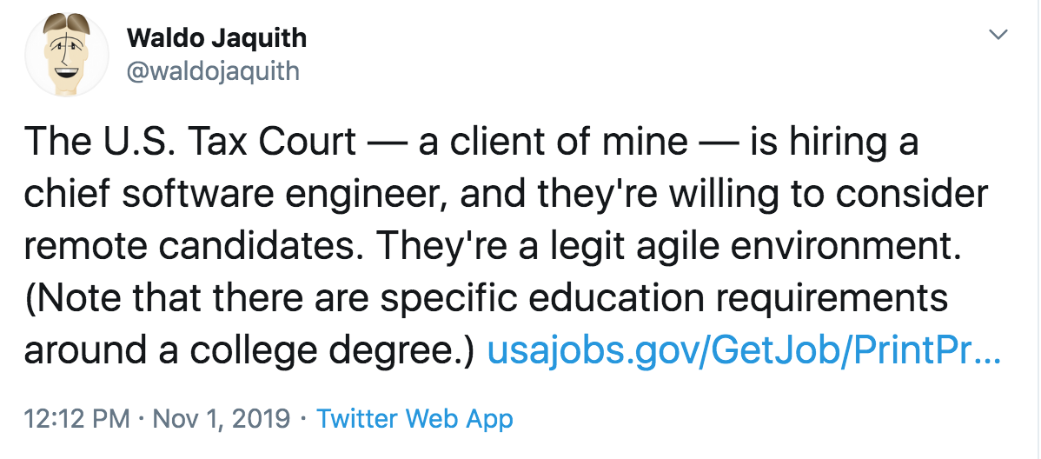<https://twitter.com/waldojaquith/status/1190300713676611585>

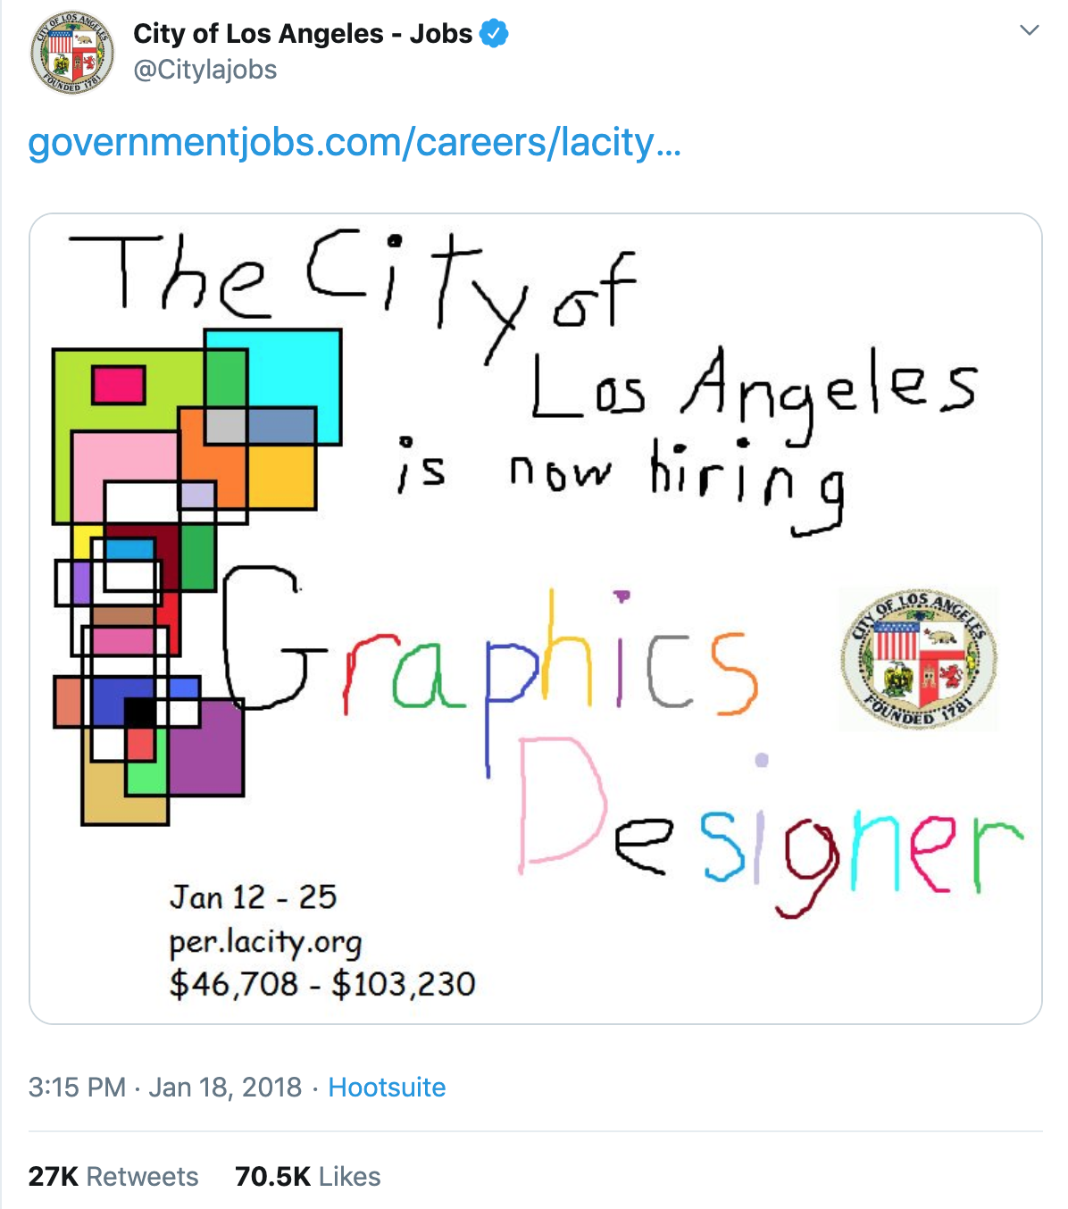

<https://twitter.com/Citylajobs/status/954084813790728193>

### Attend meetups and other events

In addition to posting your job opening online, consider attending events and meetups to personally invite candidates to apply. Here are some resources to give you ideas on where to go:

* Local Code for America brigade, like Code <For> Connecticut
* Meetups for modern technology, like:
  + Python ([The Greater Hartford Python Group](https://www.meetup.com/greaterhartfordpython/))
  + Open source (Greater Hartford Open Source Developers)
  + Javascript (Javascript Connecticut)
  + DevOps ([DevOps CT](https://www.meetup.com/DevOps-CT/))
  + Agile ([Agile Hartford](https://www.agilealliance.org/communities/agile-hartford/))
  + Salesforce ([Connecticut Salesforce Developer Group](https://www.meetup.com/Connecticut-Salesforce-Developer-User-Group/))
  + Cloud ([Connecticut AWS Meetup](https://www.meetup.com/Connecticut-AWS-Meetup/))

Going in person provides the opportunity to talk passionately about the work you do. It also allows prospective applicants to meet the people they will be working with. Emphasize that they will be in a supportive team environment and not the lone technologist.

In addition, by encouraging your team to attend technology meetups you allow them to (1) recruit (2) continuously learn new things.

### Resources

* [Ask 18F - How do you recruit employees?](https://18f.gsa.gov/2018/08/02/ask-18f-talent/)
* [How to recruit for local government in the digital age](https://www.civicplus.com/hubfs/CivicHR/PDFs/CivicHR-eBook-How-to-Recruit-for-Local-Government-in-the-Digital-Age-HR-5002-042517.pdf)

## Consider remote employees

Consider hiring remote employees. Recruiting and hiring is easier when you don't restrict the talent search to the city where the work is.

“*By 2028, 73% of all departments will have remote workers*.” [12]

Here are some of the benefits of opening the search to remote candidates:

* You can often find strong talent in less competitive markets
* You can hire talent that is unwilling or unable to relocate, expanding your choices
* Teams distributed across multiple time zones offer a longer overall workday on projects

### Resources

* [18F’s best practices for making distributed teams work](https://18f.gsa.gov/2015/10/15/best-practices-for-distributed-teams/)

## Engage candidates throughout the process

Government hiring processes can take a long time. Explain clearly on your website what the hiring process is like, from when candidates apply to their first day on the job. Include how long each step takes on average. Timelines help set expectations and might discourage candidates from applying or accepting elsewhere while they wait.

The General Service Administration’s Technology Transformation Service does this well on their jobs page.

|  |  |
| --- | --- |
| **Process Stage** | **Average Duration/Days** |
| Application collection | 5 |
| TTS application review | 5 |
| GSA HR application review | 10 |
| Interviews | 30 |
| Offer and security | 30 to 60 |
| Total from application to start | 80 to 110 |

Table from: <https://join.tts.gsa.gov/hiring-process/>

The City of San Francisco has a very high touch hiring process. They require that someone is in touch with candidates at least once a week.

“*We have gotten feedback from a lot of candidates that this was a really great interaction with government, pleasantly surprised by high touch experience.*” — Deputy Chief Digital Officer.

## Reduce the hiring time

Government hiring processes can take months — six months isn’t unusual. For candidates who are used to industry timelines, this is an eternity. You risk losing valuable candidates to a long process, especially if there is no communication between the stages. Shorter hiring processes also mean you’ll bring necessary staff on board sooner.

To shorten the hiring process:

* Work with HR to map the current hiring process
* Identify areas of improvement with the goal of reducing the overall hiring time
* Make a plan to do this regularly
* Work with HR so that you can communicate with the candidates throughout the process

The HR department may not have the metrics you’re looking for, so the first step might be measuring how long each step in the process takes.

### Resources

* <https://join.tts.gsa.gov/hiring-process/>
* [San Francisco’s 6 simple steps to hiring](https://sfdhr.org/sfcivictech)
* [California Department of Justice application process](https://caldoj.github.io/opii/apply)
* [Mobilizing Tech Talent](https://ourpublicservice.org/publications/mobilizing-tech-talent/)

## Checklist

* Write an appealing position description
  + Use plain language
  + Job titles and descriptions should be comparable to those outside government
  + Limit lists of requirements to must-haves
* Attract candidates new to government
  + Lead job descriptions with a strong mission statement
  + Include descriptions of projects candidates will be working on
* Advertise your job opening
  + Post your opening online to where the candidates are
  + Use social media to spread the word about the opening
  + Attend local meetups and other events to invite people to attend
* Consider hiring remote employees to expand your talent pool
* Engage candidates throughout the process
  + Explain your hiring process clearly on your website, including expected timeframes for each stage
  + Communicate regularly with candidates throughout the process
* Reduce the hiring time
  + Work with your HR department to map the hiring process
  + Identify and improve parts of the process that can be streamlined

|  |
| --- |
| Case study: City and County of San Francisco One might think that the overwhelming amount of digital talent in the Bay Area makes it easy to recruit for the San Francisco Digital Service. In fact, they face the same recruitment challenges as digital teams in state and local governments across the country. And they’re competing against top tech companies that pay much higher salaries than local government.  To ease and streamline their recruiting process, the SF Digital Service team:   * Builds relationships with HR staff so that they understand new technical roles and why a different hiring process is sometimes necessary * Helps out with outreach, recruiting, and interviewing * Uses a high touch model, reaching out to prospective hires at least once a week to guide them through the process * Tracks hiring metrics like passthrough rates, time to hire, and acceptance rates using modern applicant tracking software * Sets candidate expectations for salary, work environment, and government culture up front, increasing the acceptance rate for job offers |

# Hiring

It’s important to differentiate between those hiring behaviors that are done by convention and those that are specified by law. Hiring processes vary from state to state and agency to agency. Hiring and evaluations become very specific with hiring authorities, rules, and regulations.

In general, the basic hiring process should include these five steps:

1. Establish a hiring team and evaluation process
2. Workshop the candidate evaluation criteria
3. Review resumes
4. Conduct phone interviews to screen candidates
5. Hold in-person interviews

To improve your hiring process:

* Work with service design researchers to map your hiring process
* Identify areas you’d like to improve
* Partner with HR to make improvements
* Measure the impact

### Resources

* [A description of UK GDS' interview process](https://technology.blog.gov.uk/2015/07/14/applying-for-a-job-at-gds-update/)

## Establish a hiring team and evaluation protocol

For each job description, you’ll want to pull together a team to evaluate candidates. You’ll need the following roles on your hiring team:

* HR specialist
* Subject matter experts (SMEs)
* Hiring manager

The traditional resume review and hiring process is subjective and susceptible to bias. Work to ensure your hiring team is diverse. It’s also helpful to have team members attend unconscious bias training beforehand.

### Resources

* [Federal government agencies should include experts in the hiring process](https://www.govexec.com/management/2019/09/weichert-agencies-should-include-experts-hiring-process/159871/)

Workshop the candidate evaluation criteria

Because the review and hiring process is subjective, it’s important to plan how you will evaluate candidates up front. By using the same criteria and interview questions for each candidate, you reduce opportunities for introducing bias.

Get together as a hiring team to discuss and agree on how you’ll evaluate candidates during each phase of the hiring process. Then document what you come up with so that you can evaluate each candidate the same way.

To create a fair and consistent process:

* Set criteria for screening resumes — document this criteria in a checklist, using the job description as a guide
* Decide on the phone screen and interview questions in advance
* Ask all candidates the same questions in the same order
* Ensure that the questions actually test skills and experiences relevant to the position
* Ask questions based on realistic scenarios at work — but don’t use this to solve real problems or get free ideas

## Review resumes

HR will do the initial review to filter out applicants who are ineligible for employment. Then two or more SMEs (e.g. backend developers for a developer position) will need to review and determine which candidates move on to the phone screen.

Look for red flags, like an applicant who has:

* No demonstrable experience for the position they’re applying for
* A history of switching jobs too frequently — while it’s common to switch jobs frequently in technology, someone who’s moved on every few months might be a problem

### Resources

* [18F’s resume review guide for engineering positions](https://eng-hiring.18f.gov/resume-review/)
* [The best interviewing techniques and practices explained](https://medium.com/swlh/the-best-interviewing-techniques-and-practices-explained-61cf41c3175f)

## Conduct phone interviews to screen candidates

Suggested duration: 30 minutes.

For most roles, these can be conducted by HR. If you’re interviewing for leadership and executive roles, it might be better that this is done by a subject matter expert.

Use the phone screen to determine if the candidate has the qualifications necessary to do the job. You’re deciding who you’ll bring in for an in-depth, in-person interview.

* Ask basic background questions
* Confirm salary expectations
* Look for candidates who are passionate about your agency or mission, since they’re likely to be productive and motivated employees
  + Ask why they’re applying to this position
  + Ask why they’re attracted to your organization
* Clarify any parts of their resume you have questions about

Look for red flags, like:

* Lack of enthusiasm
* Lack of preparedness

## Hold in-person interviews

Suggested duration: 60 minutes.

In-person interviews should include at least one person the successful candidate will be working with directly. The candidate is evaluating you just as much as you’re evaluating them. Here are some basic tips for a successful interview:

* Create a friendly, comfortable environment for the candidate
* Limit the number of interviewers to two — anything more than that is intimidating and unnecessary
* Start and end the interview on time
* Be prepared — review their resume ahead of time, and be sure to have the interview questions with you
* You can be tough, but keep it friendly
* Remind candidates to think out loud so that you can evaluate how candidates approach problems

Follow the same interview process for each candidate:

* Introduce yourself and your role. While you already know a lot about the candidate from their resume, they don’t know anything about you.
* Ask questions.
* When there are 10-15 minutes left, let them ask you questions.
* Thank them for their time.

## Resources

* [Sample interview questions](https://firstround.com/review/40-favorite-interview-questions-from-some-of-the-sharpest-folks-we-know/)
* 18F has a great guide with several sets of interview questions
  + [Software engineer](https://eng-hiring.18f.gov/interviews/engineer/)
  + [DevOps/Site Reliability Engineer](https://eng-hiring.18f.gov/interviews/devops/)
  + [Cybersecurity/Information Security](https://eng-hiring.18f.gov/interviews/infosec/)
* [Interview questions for user experience researchers](https://medium.com/@eleonorazucconi/46-interview-questions-for-user-experience-researchers-at-google-amazon-microsoft-and-facebook-c582827267b9)
* Appendix E: Interview questions
* [18F Engineering Hiring Guide](https://eng-hiring.18f.gov/interviews/)
* [Providing tools in one place (State of Oregon)](https://www.oregon.gov/das/HR/Pages/success-plan.aspx#)
* [It's better to avoid a toxic employee than hire a superstar](https://hbr.org/2015/12/its-better-to-avoid-a-toxic-employee-than-hire-a-superstar)
* [Practical ways to reduce bias in your hiring process](https://www.shrm.org/resourcesandtools/hr-topics/talent-acquisition/pages/7-practical-ways-to-reduce-bias-in-your-hiring-process.aspx)

## Checklist

* Form a diverse hiring team
* Ensure subject matter experts are part of your hiring team
* Have all members of the hiring team attend unconscious bias training
* Document the hiring process
* Document and follow evaluation criteria for reviewing candidates
* Decide what interview questions you are going to ask and set evaluation criteria for answers
* Use interview questions that test skills and qualifications relevant to the position
* Have two or more SMEs review each resume
* Ask all candidates the same interview questions, in the same order
* Be tough, but friendly

|  |
| --- |
| Case study: USDS and OPM Historically, the federal government hiring process hasn’t involved subject matter experts (SMEs) to qualify candidates. Instead, HR specialists review resumes and questionnaires, screening candidates in and out of the pool for consideration. The result is that agencies often don't receive qualified candidates to select from.  To address this, a team at the USDS is working with the Office of Personnel Management (OPM) to implement the [Subject Matter Expert Qualification Assessments (SME-QA) hiring process](https://smeqa.usds.gov/). The SME-QA hiring process mimics best practices from the private sector and is designed for technical and other hard to fill roles at or above the GS-12 pay grade. In this revised process, SMEs work with HR to review resumes and conduct multiple rounds of interviews. Only then is an applicant determined qualified and veterans' preference applied.  The acting director of OPM [issued a memo](https://www.chcoc.gov/sites/default/files/OPM%20Memo%20Improving%20Federal%20Hiring%20through%20the%20Use%20of%20Effective%20Assessment%20Strategies%20to%20Advance%20Mission%20Outcomes.pdf) to raise awareness, encouraging agencies to try this process. While the SME-QA process is legal within current federal law, many agencies don’t take advantage of it, because they don’t know they can. Executive support — like the OPM memo — is vital for this type of change management.  With executive support, the team has worked with agency partners to hire approximately 20 qualified IT specialists to the Department of Health and Human Services and the Department of the Interior.  The [SME-QA](https://smeqa.usds.gov/hiring-phases/getting-started/)  website provides resources for other agencies and levels of government to try it themselves. |

# Onboarding

*“A new job can be stressful, and the decision to stick with a job or move on is often made within the first few days. It’s vital that we create a great onboarding experience. We never want to lose sight of the fact that people are at the heart of what we do.” [13]*

Employee onboarding is the process of integrating a new employee into your team. A good onboarding process will reduce the time it takes new employees to acclimate — and to contribute.

Onboarding consists of the following activities:

* Getting the new hire the tools and information they need to be a productive member of the team
* Introducing them to to your organization’s culture
* Orienting the new hire to your goals, priorities, and projects
* Ensuring that all of the new hire paperwork is done
* Making them feel welcome on the first day and beyond

Onboarding is a long process. It starts from the moment a candidate agrees to join the team and ends a few months after their first day on the job.

Start documenting your onboarding process with the first hire. Even a small amount of simple documentation will improve this important process. And as new employees get up to speed, invite them to participate in making onboarding even better for the next new hire.

## Onboard in phases

To avoid overwhelming new hires — or underwhelming them — treat onboarding as a phased process. Break it down into the pieces that make sense at each stage. The suggestions below will help you build a tailored onboarding guide and corresponding checklist.

### Before the first day

Preparing for your new employee starts well before their first day. You’ll want to have a number of things in place:

* Order the hardware (e.g. laptop, phone) the new hire will need — and be sure to leave enough time for IT to configure it and ensure it’s ready on the first day
* Purchase any additional licenses and accounts for any software needed
* If they are going to physically be in an office, figure out where they are going to sit and get the space ready for them
* If they are going to be remote, make sure to ship whatever they’ll need to have on hand for the first day (e.g. laptop)
* Assign them to a team or project and give the team time to prepare concrete tasks to get the new hire started
* Schedule time for them to meet the team
* Assign an onboarding buddy to guide them through the first few weeks on the job and:
  + Facilitate meeting people
  + Provide them with any informal context to the work and relationships
  + Answer any questions about cultural norms, etc.
* Send them any first day instructions, such as what documents to bring, what time to come in, dress code, etc.

### On the first day

First impressions are important and lasting. Make your new hire feel welcome on their first day, and:

* Have them complete the necessary paperwork
* Give them their laptop and walk them through setting up their accounts and access to any software they’ll need
* Get them access to your team chat
* Introduce them to your organization through chat or email (have them provide an introductory blurb)
* Introduce them to their onboarding buddy
* Have the onboarding buddy schedule coffee or lunch with the new hire

### The first week

* Encourage team members to schedule 1:1s with the new hire to welcome them and give an intro to the different projects throughout the organization
* Schedule deep-dives for the project they will be involved with

### Ongoing

It will take time for new employees to adjust to your environment and start becoming productive. Keep engaging with them during this early period, as they will need lots of help navigating your organization. Schedule regular check-ins, and ask them how they’re settling in.

## Create an employee handbook

Create an employee handbook that’s easy for everyone to access. A well-written handbook becomes the source of practical information and documentation of your culture. In addition to the normal HR related things, here are some topics to include in your handbook:

* How to get help with technology
* How to request software licenses
* How to request new software
* A link to the organization’s Code of Conduct
* Documentation around best practices for making remote teams work
* A guide to the acronyms and initialisms that are so popular with government agencies

## Checklist

* Build an onboarding process and guide
* Create an onboarding checklist for new hires
* Create an employee handbook
* Ask new hires to make updates to the onboarding guide, onboarding checklist, and employee handbook

## Recommended reading

* [18F's onboarding schedule](https://handbook.18f.gov/onboarding-schedule/)
* [Making a great first impression: onboarding matters](https://digital.canada.ca/2019/07/29/making-a-great-first-impression-onboarding-matters/)
* [How we dramatically improved 18F's onboarding process in 3 months](https://18f.gsa.gov/2015/12/01/how-we-dramatically-improved-18fs-onboarding-process-in-3-months/)

### 

|  |
| --- |
| Case study: Coding it Forward Since 2017, Coding it Forward has brought over 100 undergraduate and graduate students into the federal government through their Civic Digital Fellowship. In addition to delivering real value to the agencies where interns are placed, the Fellowship is educating the next generation of our civic workforce.   Most interns are used to working in tech companies, so Coding it Forward proactively manages their experience to ensure a smooth transition to government culture. Each intern is paired with a mentor to help them navigate the civic tech world, introduce them to the community, and provide valuable guidance and support.  Agencies must host at least four interns to build community among the interns and ensure that no one is isolated at their agency. To help create positive experiences and spread the word about civic employment to other young people, plan social events, demos, and opportunities [for interns to share their work publicly.](https://github.com/codingitforward/cdfdemoday2019) |

# Ensuring happy and engaged employees

“J*ust as interacting with government can be hard, working within government to improve those interactions is also hard. People management is hard, the silos are hard, the bureaucracy is hard*.” [CITATION NEEDED]

Recognize that working within the government is hard. And in today’s economy, digital talent have plenty of job opportunities. You’ll need to make an effort to ensure your employees are happy and engaged with their work.

Following many of the recommendations throughout this handbook will help make for happy and engaged employees. Here is a recap of some of the most important steps you can take:

* Select **interesting projects** where traction is possible. Scope down problems that are too large to succeed.
* Partner with program offices that are willing to **embrace new ways** of working.
* Encourage a **work/life balance**. During project planning, take into account vacations and time off. Work with others in your organization to ensure deadlines and scope are realistic.
* Make it easy to **work from home**.
* Create opportunities for **professional development** and exposure to new ideas. Encourage your team to attend conferences, meetups, and other events.
* Create a **generative organizational culture**.
* Ensure that your physical and virtual environments **encourage collaboration**.
* Create a **career path** for all roles on your digital team.

# Keeping skills and ideas fresh

Technology evolves at a fast pace, and people are constantly inventing new ways to solve problems. Keeping up with this pace is important — and luckily, your employees probably want to do so. When asked why they might leave their current position, professionals cite the ability to learn and grow on the job as being almost twice as important as salary.[14]

Make time for your team to learn and grow as part of their job. This means making time for longer, more time-intensive programs, but it also means baking learning opportunities into everyday work.[15]

## Offer opportunities for continual learning

Data from the Office of Personnel Management show that 51% of information technology professionals in the federal government were 50 years of age or older.[16] In Connecticut’s state government, a very low number of IT personnel are under age 40.

Due to a lack of significant training in modern technology, the skills and training of the workforce are several generations out of date.3

You must plan to offer incentives and opportunities for continuously training your staff. Your staff need to keep up with the pace of change in technology. Offer opportunities for training, but also for using those new skills in the workplace.

High quality courses are available online from companies like: [Udacity](https://www.udacity.com/), [edX](https://www.edx.org/), [coursera](https://www.coursera.org/), <https://www.agilegovleaders.org/academy/>. [General Assembly](https://generalassemb.ly/) offers practical in-person classes.

Technology staff will benefit from the opportunity to learn new languages, tools, and technologies. General government staff should learn agile project management and design thinking, among other topics. Digital transformation requires everyone to participate.

“*Our comprehensive program of leadership training and development both increases employees’ professional development and career potential and strengthens networking among promising employees moving upward into more responsible positions*.” [17] — Bob Oglesby, Commissioner of General Services for the State of Tennessee

In Brazil, for example, the federal school of government is implementing a training program in digital transformation: [Capacita Gov .BR](https://www.enap.gov.br/index.php/pt/nossos-cursos/programa-de-capacitacao-em-transformacao-digital)

“In the United Kingdom, for instance, the Department for Work and Pensions (DWP) created a boot camp-style digital academy to train and upskill staff. Workers are trained on key elements of digital technology such as user-centric design, agile development, and digital government services.[6](https://www2.deloitte.com/us/en/insights/industry/public-sector/state-leadership/a-state-workforce-to-meet-modern-challenges.html#endnote-19) While started by the DWP in 2014, the Digital Academy has now been expanded to provide digital training to the rest of the UK government.”

Eggers et. al write about different types of learning and how learning should eventually become part of the flow of work.[18]

## Make it easy for staff to attend conferences

Many agencies have a training budget. Make it easy for staff to use this budget to attend industry technology conferences. These conferences provide lots of opportunities to learn from each other's practical experience.

Some conferences worth attending:

* [Conferences from technology publisher O’Reilly](https://www.oreilly.com/conferences/)
* [Strange Loop](https://www.thestrangeloop.com/)
* [An Event Apart](https://aneventapart.com/)

## Recommended reading

* [Maine Workforce 2025](https://www.maine.gov/bhr/sites/maine.gov.bhr/files/inline-files/MaineWorkforce2025.pdf)
* [Agile Government Leaders Academy](https://www.agilegovleaders.org/academy/)

### 

|  |
| --- |
| Case study: Peak Academy “*Peak Academy trains and coaches employees at all levels to improve the way government works. Through innovation, employees do more with less and enhance the Denver city experience*.” — Mission Statement of [Denver’s Peak Academy](https://www.denvergov.org/content/denvergov/en/mayors-office/programs-initiatives/peak-performance/peak-academy/About.html)  Too often, government teams are focused on getting more staff, technology, and money, which are all usually hard to come by in local government. So how do you do more with less?  Brian Elms of Denver’s Peak Academy has an answer — focus on solving a problem, not on increasing resources.   * Create a language for how to solve a problem. When everyone on the team is talking about a problem in the same way, they have a shared understanding of that problem and can spend more time solving it. * Focus resources on the performance indicators that matter most; it’s impossible to tackle every problem at once. * Foster collaborative problem solving, bringing voices from across the government into one room to solve a problem. * Tie funding to innovative programs. Quantify change in terms of dollars saved to make it easier to allocate budget to training and similar initiatives. * Frame the problems from the customer’s perspective. If possible, bring a customer representative into process mapping sessions so that the team understands their point of view.   Some cities are replicating Denver’s success with their own Peak Academies. Others are focused on training their innovation teams, or smaller groups focused on more specific problems. Here are some examples:   * In 2017, Chattanooga, Tennessee started their own [Peak Academy](https://connect.chattanooga.gov/opmod/performance-management/peak-academy/) with no budget or dedicated staff. They have trained over 100 employees and saved over $100,000. * In Miami, the procurement department sent all of their employees to the Miami Innovation Academy and have since streamlined the process for procuring engineering services. They’ve cut out 40% of the forms and at least 30 days of wait time.[19] * The City of Durham publishes [training resources online](https://durhamnc.gov/3753/OPI-Trainings-Resources) so anyone can learn about Lean and other innovative strategies for problem solving.   As more state and local governments adopt this training mentality, Elms sees that many others hesitate to allocate already overworked resources to set up and implement the program. “You can dip your toe in the water and have some success. But if you jump in, you’ll have tremendous success,” he says.[20] |

# Building a movement and a presence

Share your team’s mission and work by building a brand and a presence — both online and in person — as part of your communications efforts.

Building this presence will help you:

* Communicate with and engage key stakeholders in your mission and vision
* Share successes and lessons learned, capturing the work you’ve done and its impact
* Drive team culture by sharing how you work
* Attract potential employees and help grow supporters and audiences to engage further

## Define and understand your audience

Define your target audiences with an understanding of what you would like to communicate to them and what they’d like to get from you. Since resources and capacity are rarely unlimited, it’s best to identify two to three primary audiences to focus on in your communications and engagement efforts.

Your target audience may vary over time. For example, as you stand up your team, you might focus on attracting new recruits. As your team matures, your target audiences could expand to include the public, government leaders and legislators, and other, similar digital teams. Identifying and understanding your audience and objectives from the start will also allow you to evaluate the impact of your communication activities later on and adjust them accordingly.

## Build and maintain an online presence

You’ll first want to figure out your team’s capacity for establishing and maintaining communication channels. For example, having a blog or social media account that you rarely update can be worse than not having one at all. Whichever channels and tactics you choose, you’ll need to update them regularly to maintain a steady presence.

### On authenticity

Plan for ongoing engagement with your audience that’s not just about you and what you want. Think about it as building a relationship that goes both ways. In addition to sharing news and highlights of your work, include communication touch points that offer value by way of helpful information and opportunities to connect in meaningful ways.

You’re building a presence and a relationship with your audience. You will build a reputation for your work and methods over time.

## Go to where your audience is

Now that you’ve identified your audience and developed a plan that takes the teams capacity into account, use communication channels where your audience and community are already present. This makes it easier on your team and helps you reach your audiences more effectively.

Your audience is unlikely to visit your agency or government website regularly to get the latest information. Target specific social media platforms based on your audience and experiment with new posts and advertising. Evaluate engagement and adapt your tactics as needed.

Here are some popular channels to consider:

* [Medium](https://medium.com/) is a great place for blog posts and articles if you don’t already have a blogging platform set up. Medium is also a useful platform if you’re not posting long form articles regularly, and it makes it easy to share on other social media platforms. Examples include: [Massachusetts Digital Service](https://medium.com/massgovdigital), [City of Austin Texas](https://medium.com/civiqueso), [NYC Planning Labs](https://medium.com/nyc-planning-digital)
* The [Twitter](https://twitter.com/?lang=en) format is ideal for promoting blog posts, events, and hiring calls. Also use Twitter to engage in conversations with the community. Examples include: [Georgia Digital Service](https://twitter.com/georgiagovteam?lang=en), [Canadian Digital Service](https://twitter.com/cds_gc?lang=en), [Massachusetts Digital Service](https://twitter.com/massgovdigital?lang=en)
* It’s not a public forum, but [Slack](https://slack.com/) gives you the opportunity to engage in a bi-directional way with your audience through Slack communities for civic technology and related interest groups within your state.
* Other social media platforms such as [Instagram](https://www.instagram.com/) or [YouTube](https://www.youtube.com/) can be used to share photos or videos of events you host or participate in. Examples include: [DigitalGov’s Youtube Channel](https://www.youtube.com/channel/UC5V8jrK77-8gsa9RL_taG9A)

## Develop a basic web presence

Regardless of which combination of online channels you choose, you’ll still need a basic website to serve as the digital home for your work.

A public-facing website provides a go-to place for project partners and potential candidates to get more information. Consider including a concise outline of the mission and the potential for impact. This will humanize the call to service for recruiting.

Establish your public website as early as possible. As with everything, iteration is key. Start by putting up a minimal version of the website and expand it later as the concept and value of the team is further refined.

For example, consider as a minimal viable product:

*A single page with some basic introductory text and an email address to contact you; the initial focus and use would be recruitment*

A second iteration might include:

*Changing the perception that government is a boring, bureaucratic place to work by adding information about the mission and impact of upcoming projects*

The story behind a digital team should never stop evolving. Transition the focus of the online presence from recruitment to a more sustainable resource when you’re ready.

Here are two examples:

* A minimal web presence from the [Colorado Digital Service](https://sites.google.com/state.co.us/coloradodigitalservice/home)
* A [larger presence from New Jersey](https://innovation.nj.gov/), with all the necessary elements that a digital team website might need

### Making it official

Use one of the following methods to convey that your new digital services site is official:

1. Host it on your government’s domain (for most states this will be .gov).
2. Create a redirect
3. Link to your site hosted elsewhere from an existing webpage

## Invite your team to share their work and stories

Invite your team to share more and more often. Ask your team to write about the projects they work on, workshops they host, and events they attend. By talking about the work you’re doing — and how you’re doing it — you’ll ensure that:

* The work is transparent to the public and other government officials
* Potential job applicants understand the types of projects they will be involved in and they might even apply to work on specific projects.
* The barriers between teams are lower, because other teams know what you’re working on
* You’re building a repository of the team’s work as you share it

When you share your work techniques in blogs or in workshops, this helps:

* Bring new hires up to speed
* Convince program offices to work with you
* Build buy-in for new ways of working among other teams in government

On a broader scale, writing about your work helps other digital services teams get started too. For example, 18F learned a lot from the Government Digital Service as it was being stood up.

Sharing your work doesn’t always have to be long-form articles. Embrace the conventional and unconventional. For example, you can share work effectively through threads and posts on Twitter. We’ve included some examples below.

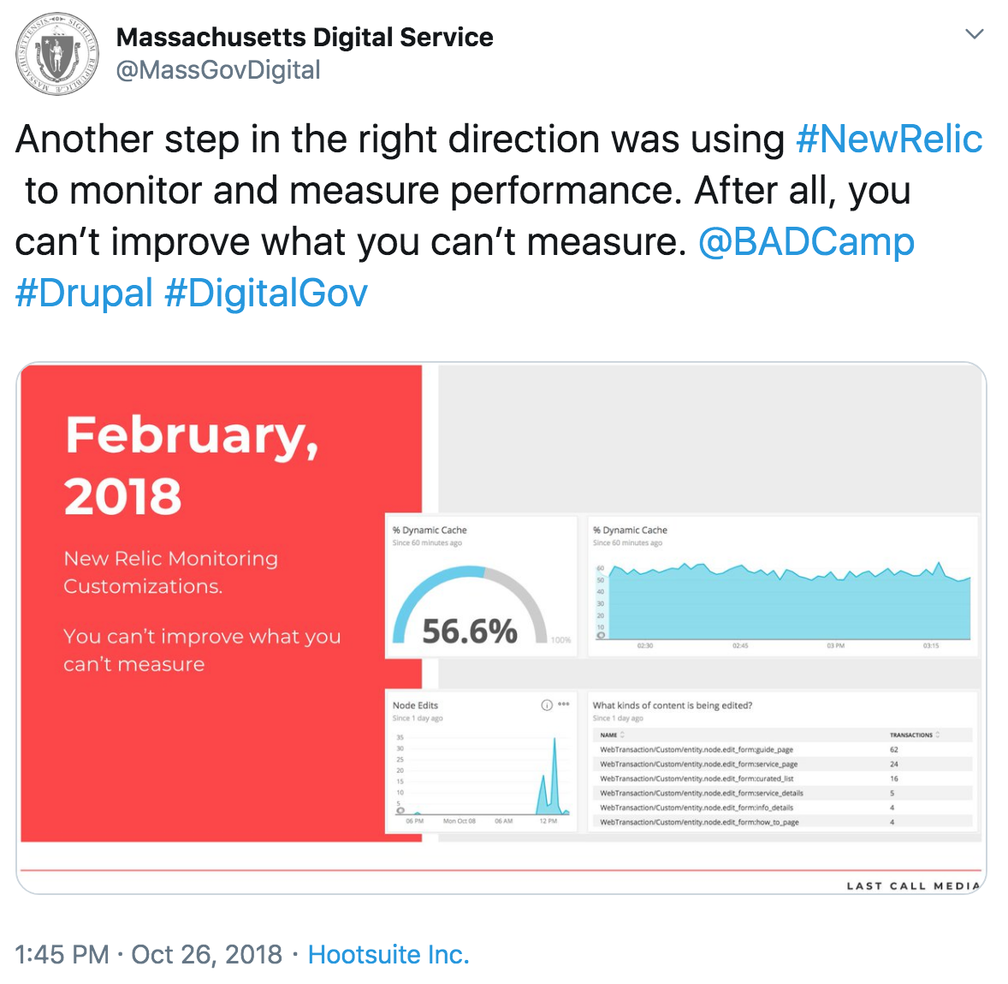

Source: <https://twitter.com/MassGovDigital/status/1055878033415041024>

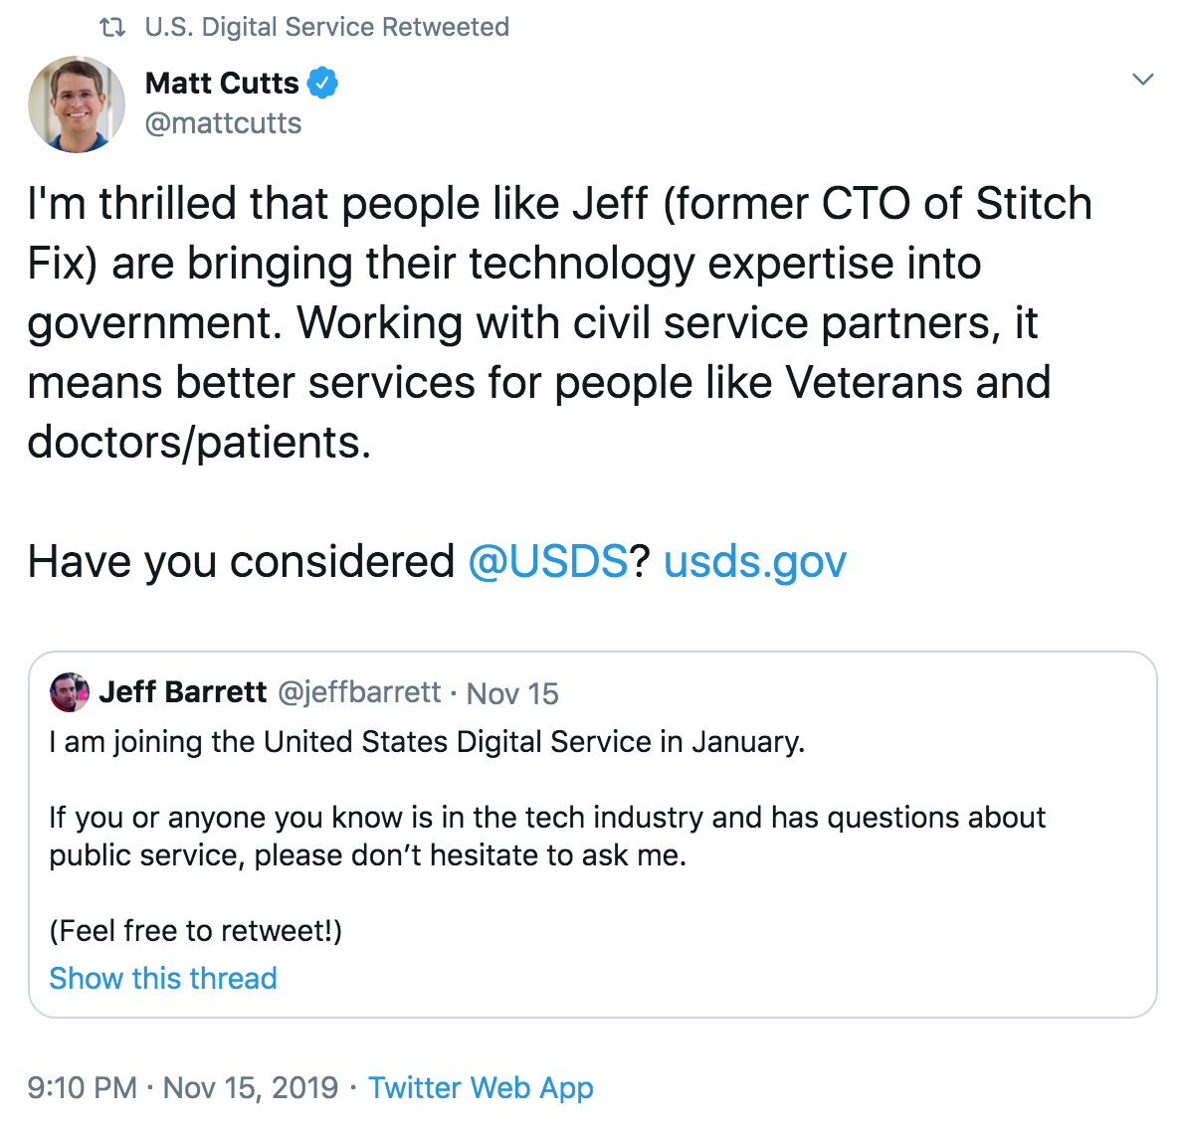

Source: <https://twitter.com/mattcutts/status/1195524566602395649>

## Participate in meetups and conferences

Meetups and conferences are opportunities for your team to learn, present their work, recruit, and get energized by new ideas.

### Participate in local meetups

Participate in local meetups regularly. Local meetups are attended by the very people you serve, and the problems you’re solving affect them. This presents the best pool of folks to recruit from. Plus, your team members may enjoy talking about the work they’re doing.

Search on [Meetup](https://www.meetup.com/find/groups/) for events near you.

### Attend national conferences

Send your team to national conferences that are aligned with the work. They will meet other folks working on similar problems and technology, and they will benefit from attending or speaking. Attending conferences encourages your team to bring back new ideas and methods. Speaking at conferences gives them an opportunity to be proud of the work they’ve done.

**Recommended conferences**

* A good civic technology conference to attend and speak at is the [Code for America Summit](https://www.codeforamerica.org/summit)
* [SXSW](https://www.sxsw.com/) in recent years has hosted many government and government adjacent topics

## Checklist

* Define and understand your audience and set objectives
* Figure out your team’s capacity for establishing and maintaining communications channels
* Pick which communication channels you’ll maintain regularly
* Build a basic online web presence
* Share what you’re working on and how you do the work
* Attend and speak at national conferences, local meetups and other events regularly
* Be authentic: maintain a presence even when you don’t want something from the community

## Recommended reading

* <https://medium.com/civiqueso>
* <https://www.codeforamerica.org/>
* <https://digitalservices.georgia.gov/>
* <https://www.newamerica.org/public-interest-technology/>
* <https://digitalservices.georgia.gov/>
* <https://playbook.cityofnewyork.us/>

|  |
| --- |
| Case study: Bloomberg Cities Mayor Michael Bloomberg’s [American Cities Initiative](https://www.bloomberg.org/program/founders-projects/american-cities-initiative/) promotes bold leadership and effective decision making, supports critical policy actions, and encourages residents, entrepreneurs, and more to uplift cities and solve problems. Through active [Twitter](https://twitter.com/BloombergCities) and [Medium](https://medium.com/@BloombergCities) accounts, Bloomberg Cities tells engaging stories of local change.  They use Medium extremely effectively, writing interesting, concise, and clear stories that [describe inspirational leadership](https://medium.com/@BloombergCities/mayors-how-executive-training-helped-me-innovate-in-city-hall-fffbbb8afecd), [outline how cities are doing things differently](https://medium.com/@BloombergCities/innovation-in-the-heartland-how-sioux-falls-is-turning-public-problem-solving-on-its-head-1fc843a9f12f), or [provide specific steps to facilitate change](https://medium.com/@BloombergCities/7-ways-to-build-a-culture-of-innovation-in-city-hall-aa18b41b307). These articles are an example of how to develop a digital storytelling presence that motivates the public to get involved and take ownership to change their communities.  It’s not enough to simply post great stories — you have to make sure people will find and read them. In order to spread a mission or develop a brand, stories must be shared through the civic tech and larger government community. Share articles with relevant local groups, ask influential colleagues to tweet them out, and send them to civic tech mailing lists.  If your network is limited, you can start by publishing articles through existing platforms that already reach your audience. As you build momentum, you’ll also build your network and reach. |

# Addressing Connecticut-specific challenges

To understand the State of Connecticut’s challenges, we conducted a Digital Capability Assessment workshop in June 2019. The workshop covered a range of topics critical to technology delivery, including digital talent management.

The following observations are based on what we heard from workshop participants.

## Observation #1: There’s a lack of digital talent capacity

There is a lack of internal digital talent within the State. Almost all of the technology staff are contractors. The existing technology workforce represents legacy skill sets. The state wants to modernize and fix a number of existing systems, but doesn’t have the capacity to do so.

### Recommendations

* Understand and quantify your digital talent gaps.
* Build a holistic talent strategy.
* Continue to build out a cross-functional CT Digital Services team. Focus on increasing the digital talent density across the state. This is your bright spot, to help recruit additional digital talent.
* Assemble high-impact, cross-functional digital teams around specific initiatives or services.

### Relevant sections

* Understanding your talent gaps
* Digital Talent Strategy
* Skills and composition of a digital team

## Observation #2: The work environment doesn’t support collaboration

The current work environment — including the physical space and tools — doesn’t support the collaborative ways individuals and teams need to work.

“*We recently had someone quit within two weeks because the environment isn’t set up to support the way they were expecting to work*.”

“*People work behind closed doors. There is no physical or virtual space to facilitate more open collaboration.*”

### Recommendations

* Accelerate the rollout of the collaboration tools that are already in place today, such as Microsoft Teams.
* Consider converting existing office space into a more open, collaborative environment.
* Empower teams to make decisions about which tools they need to succeed. Then simplify the process for agency staff to request and receive what they need.

### Relevant sections

* Creating a productive and collaborative work environment

## Observation #3 It’s difficult to hire and retain digital talent

There are a number of challenges that make it difficult to acquire and retain digital talent:

* Constraints, such as salary limitations
* Traditional approaches to hiring, including the current job classification system
* Management practices, like inflexible work arrangements

### Recommendations

* To generate a stronger applicant pool, modernize job descriptions. Current job descriptions are antiquated and don’t speak to the actual role. Work with HR to create flexibility with job titles and requirements.
* Design and launch a branding and communication campaign around the CT Digital Service and digital transformation writ large, to attract the right talent. Focus on the impact of the work.
* Since it will always be difficult for government to compete with large technology companies on salary, consider other ways to attract digital talent:
  + Allow flexible working hours
  + Allow remote work
  + Make a commitment to supporting work/life balance
  + Ensure that the work is always impactful, and that teams understand the impact of their work

### Relevant sections

* Recruiting
* Hiring
* Onboarding
* Ensuring happy and engaged employees
* Keeping skills and ideas fresh
* Building a movement and a presence

## Observation #4 The management model doesn’t support self-organizing teams

The current management model isn’t conducive to empowered, cross-functional teams. While there are a number of cross-functional teams in government, they’re not empowered to act on their own. Making changes always requires multiple levels of approval.

### Recommendations

* Develop and deliver training to executives on the new management models and behaviors that are critical to becoming a digital government. This requires moving from a bureaucratic culture to a generative one.
* Identify key digital and IT leadership positions that need to be filled now or in the very near future. Ensure that modern, technology-savvy executives are hired into those positions. Getting the right leadership in place is the most important factor in building a digital organization.

### Relevant sections

* Leading and managing a digital team
* Building a modern team culture

# How we wrote this guide

Research for this handbook was conducted as part of an engagement with the State of Connecticut. This research included the following activities:

* Desk review of many articles, blog posts, and reports from digital service teams, commercial industry, government organizations, and academic institutions
* Interviews with leaders of existing digital service teams
* Team members’ personal experiences hiring, onboarding, and managing digital service teams

# Appendix A: Interview questions

## Interview questions for UX Designers

These are questions we’ve used in the past to evaluate UX designers.

### Project walkthrough

* Walk us through a couple of your favorite projects in your portfolio
  + What was your design process?
  + What problems were you trying to solve?
  + How did you make certain design decisions?

**Discovery exercise**

The government wants to implement an advanced data analytics tool to help doctors get better insight into their patients. We currently have access to the patient database. The data is vast. Timelines are aggressive.

* Who would you interview to learn more about what’s needed?
* What exercises would you conduct to define product scope and vision?
* How would you define and measure success for a project like this?
* What does your discovery plan look like?

1. <https://www.newamerica.org/public-interest-technology/reports/problem-solving-government/what-should-teams-look-like/>
2. <http://s3-us-west-1.amazonaws.com/codeforamerica-cms1/documents/Delivery-Driven-Government.pdf>
3. [Delivery Driven Government](http://s3-us-west-1.amazonaws.com/codeforamerica-cms1/documents/Delivery-Driven-Government.pdf)
4. <https://ourpublicservice.org/publications/mobilizing-tech-talent/>
5. [Job One: Reimagine Today's State Government Workforce (2019)](https://collaborate.nasca.org/HigherLogic/System/DownloadDocumentFile.ashx?DocumentFileKey=3cbd8f19-fd2e-c0c6-3575-f64cc9cdf35f&forceDialog=0)
6. [The origins of this quote are debatable](https://www.forbes.com/sites/andrewcave/2017/11/09/culture-eats-strategy-for-breakfast-so-whats-for-lunch/#229c7c597e0f)
7. Forsgren, N & Kim, G & Kerstnen, N & Humble, J. (2014). [2014 State of DevOps Report.](https://www.researchgate.net/publication/263198947_2014_State_of_DevOps_Report) 
8. <https://content-guide.18f.gov/inclusive-language/>
9. <https://en.wikipedia.org/wiki/Unconscious_bias_training>
10. “[A Better Place to Work](https://medium.com/ontariodigital/a-better-place-to-work-8e6ab2422d47)” Kelsey Merkley on Medium, June 20, 2019.
11. <https://hbr.org/2014/08/why-women-dont-apply-for-jobs-unless-theyre-100-qualified>
12. [Upwork Future Workforce Report (2019)](https://www.slideshare.net/upwork/future-workforce-2019-how-younger-generations-are-reshaping-the-future-workforce/1)
13. <https://digital.canada.ca/2019/07/29/making-a-great-first-impression-onboarding-matters/>
14. <https://joshbersin.com/2018/11/corporate-learning-does-drive-happiness-productivity-too/>
15. <https://www2.deloitte.com/us/en/insights/industry/public-sector/future-of-work-in-government.html>
16. <https://ourpublicservice.org/publications/mobilizing-tech-talent/>
17. <https://collaborate.nasca.org/HigherLogic/System/DownloadDocumentFile.ashx?DocumentFileKey=3cbd8f19-fd2e-c0c6-3575-f64cc9cdf35f&forceDialog=0>
18. <https://www2.deloitte.com/us/en/insights/industry/public-sector/future-of-work-in-government.html#endnote-sup-11>
19. “[What happens when an entire city department is trained to innovate?](https://medium.com/@BloombergCities/what-happens-when-an-entire-city-department-is-trained-to-innovate-b8ff4772161b)” Bloomberg cities, September 25, 2019.
20. “[Replicating Denver’s Peak Academy: a conversation with Brian Elms](https://medium.com/@BloombergCities/replicating-denvers-peak-academy-a-conversation-with-brian-elms-8a24d5b5be0e)” Bloomberg cities, September 14, 2018.